**WE-I OTA v2.1.0 Usage Guide**

V0.1

Contents

1. History 3

2. Introduction 4

2.1 OTA UPGRADE FLOW – 2nd Bootloader 4

3. WE-I Host OTA v2.1.0 tool 6

3.1 COMMAND LIST MENU 7

3.2 UPGRADE LIST MENU 7

3.3 UPGRADE LIST MENU 7

3.3.1 Boot up from I2C 8

3.3.2 Load Audio PCM data to WE-I 8

# History

|  |  |  |
| --- | --- | --- |
| Version | Date | Description |
| V0.1 | 2020-06-04 | Draft version |
| V0.2 | 2020-08-31 | Modify OTA flow picture |
|  |  |  |

# Introduction

WE-I support Over-The-Air firmware update via I2C bus. WE-I should enable CPU and execute the firmware that support OTA firmware uploader. The OTA firmware uploader defines several i2c command to support data transfer. The host/soc need follow the i2c protocol to transfer firmware image to WE-I as Figure 1-1.

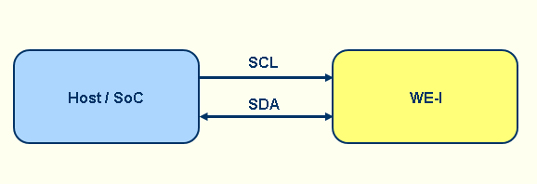

Figure 1-1 I2c protocol to transfer firmware image to WE1

## 2.1 OTA UPGRADE FLOW – 2nd Bootloader

The OTA process is done in the 2nd Bootloader. Figure 2-1 illustrates the architecture of the OTA upgrade flow in 2nd bootloader.

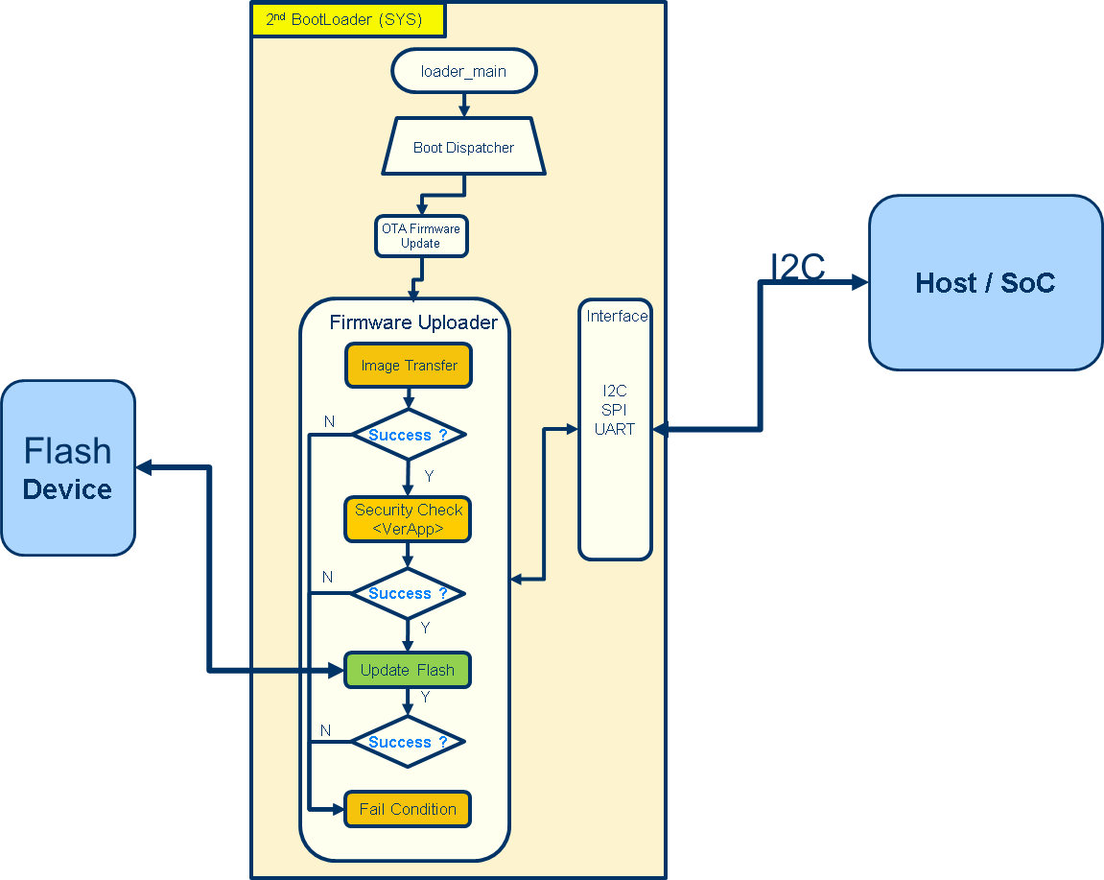

Figure 2-1 WE1 Architecture - 2nd Bootloader

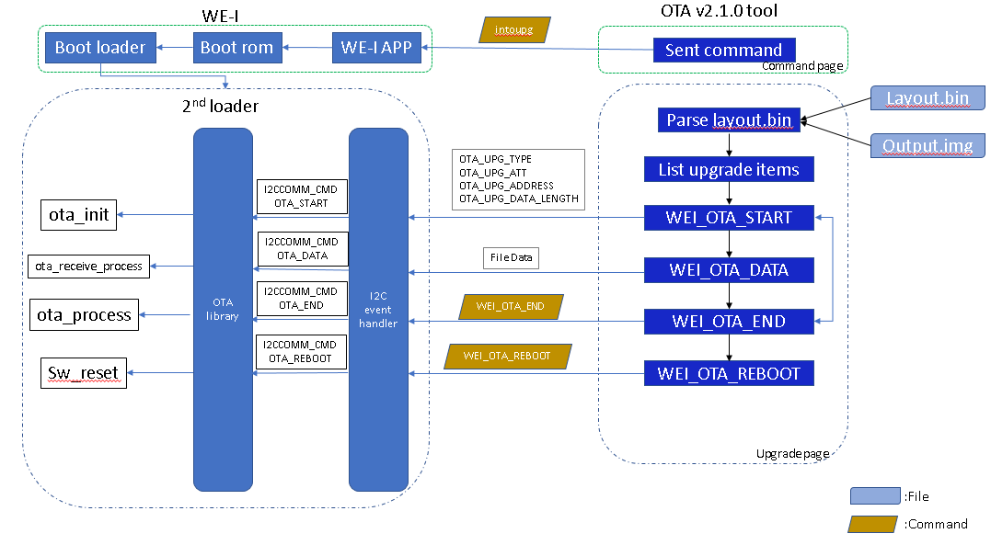

Figure 2-2 WE1 OTA flow

# WE-I Host OTA v2.1.0 tool

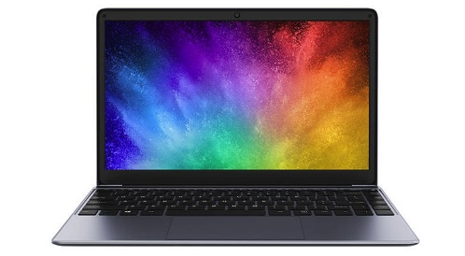

**OTA tool**

**USB**

**Converter board**

**WE-I**

**I2C**

The OTA v2.1.0 tool is a list menu tool provide user convenience.

Execute the ota.exe will show list menu as below:

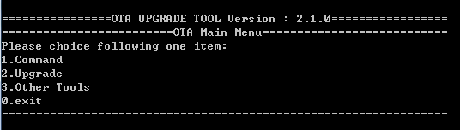

OTA Tool Version be shown in title, please use the corresponding version of 2nd loader (OTA loader).

Old version 2nd loader need to do FORCE UPGRADE new image which include new 2nd loader by use old ota tool.

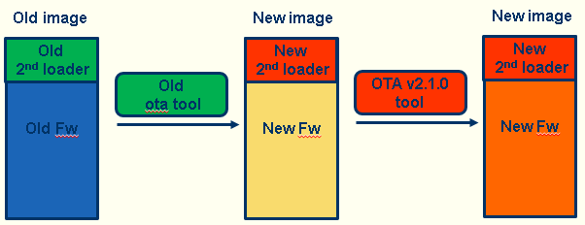

New 2nd loader will show the corresponding version of ota tool as below:  
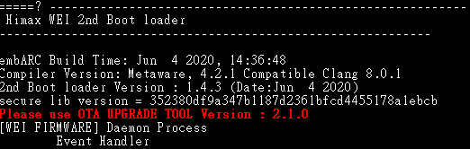

## 3.1 COMMAND LIST MENU

1.Intoupg (Application reboot to 2nd loader)........[APPLICATION]

2.Getstatus (Get WE-I current status)....................[APPLICATION/OTA LOADER]

3.Read WE-I Chip id...............................................[APPLICATION]

4.Close WE-I PDM module....................................[APPLICATION]

5.Get Audio Result................................................[APPLICATION]

6.GetVersion.........................................................[OTA LOADER]

7.GetProject id......................................................[OTA LOADER]

8.ReBoot WEI........................................................[OTA LOADER]

## 3.2 UPGRADE LIST MENU

There must be exist layout.bin & output.bin in OTA_Tool_v2.1.0/img folder. The ota v2.1.0 tool will parse the layout.bin and show all sector of image in screen as below:

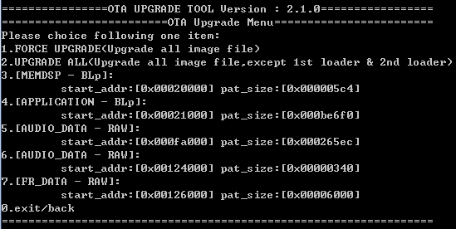

All choice items both upgrade the memdsp automatically.

## 3.3 UPGRADE LIST MENU

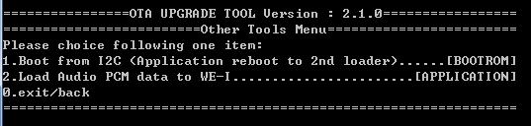

### 3.3.1 Boot up from I2C

**Condition:**

* **Execute boot from i2c only when** 
  + **flash bootloader is not existed or**
  + **bootloader verified failed or**
  + **Boot option = 011**
* **I2C clock: 400K**

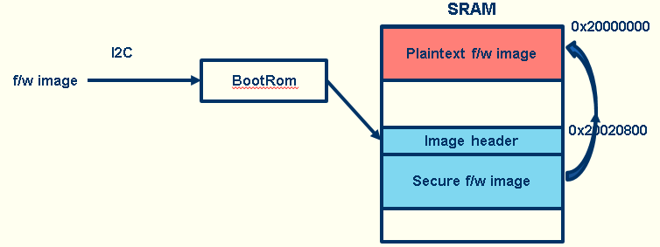

* WE-I bootrom:
  + Receive f/w image from i2c to SRAM address 0x20020800
    - 0x62 + length of each i2c command
    - 0x62 + total file length
    - 0x62 + payload
  + Verify aned move to 0x20000000
  + Jump to 0x20000000
* Note: f/w image execute address should be 0x20000000
* Note that the f/w image size should smaller than 128K. Do not overwrite 0x20020800.

### 3.3.2 Load Audio PCM data to WE-I

For Audio recognition test need to test api in WE-I.